**Web Scraping Customer Reviews from Flipkart**

**Problem Statement**

In today's data-driven world, customer feedback and reviews play a crucial role in shaping purchasing decisions. As data scientists, it's essential to be proficient in extracting and analyzing customer sentiments from online platforms. Flipkart, one of India's leading e-commerce giants, hosts a diverse range of products with a wealth of customer feedback.

**Objective**

The objective of this assignment is to develop web scraping skills by extracting customer reviews from the Flipkart website. This exercise will provide you with practical experience in accessing and parsing web content, handling pagination, and structuring data for analysis.

**Task**

Your task is to write a Python script that automates the process of extracting customer reviews for a specific product category on the Flipkart website. This script should be capable of efficiently retrieving reviews from multiple pages and storing them in a structured format for further analysis.

Extract the following information:

1. Reviewer Name
2. Reviewer Rating
3. Review Title
4. Review Text
5. Place of Review
6. Date of Review
7. Up Votes
8. Down Votes

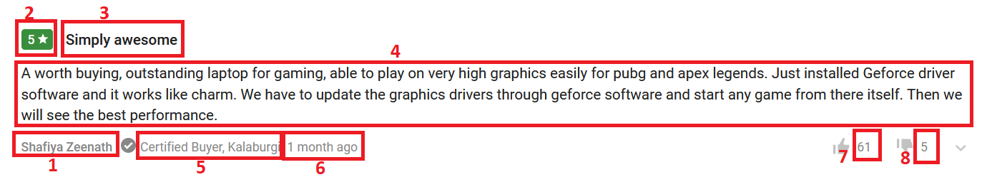

**Deliverables**

- Python script(s) for web scraping customer reviews.

- CSV file containing the scraped data.